With the Staying Well Programme
The Staying Well course is a FREE six-week programme for people living with long term health conditions.
Name :
Address:
Contact No:
Mobile:
Email:

Long term health conditions:

Special needs if any:

Health Professional details:
Name:
Job Title:
Contact Number:

Preferred course location: Retford ☐ Worksop ☐ Other ☐ Please specify
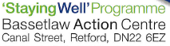
Completed forms to be sent via email to: stayingwell@bassetlawactioncentre.org.uk
or posted to the above address.

